**Dufuna Code Camp**

Product Requirements Document

E-COMMERCE WEBSITE

Product Requirements Document

1. Objective

2. Release

3. Features

4. User flow and design

5. Analytics

6. Future work

# Objective

|  |  |
| --- | --- |
| Vision | *The Biggest Online Store for Art and Crafts in Africa.* |
| Goals | *Roll out a MVP by March 2020* |
| Persona(s) | *Artists and Craftsmen, Art Collectors, Interior Decorators and Afrocentric lovers.* |

# Release

|  |  |
| --- | --- |
| Release | *Version 1* |
| Date | *March 2020* |
| Milestones | *Develop ArtShop E-Commerce Store* |

# Features

|  |  |  |
| --- | --- | --- |
| **Feature** | **Stories** | **Notes** |
| Homepage | User should be able to view promotions and deals  User should be able to search for products  User should be able to see various products and categories  User should be able to see a snippet of reviews from customers  User should be able to see a snippet of blog posts  User should be able to see company info and contact  User should be able to see return/ exchange policy and FAQ  User should see a newsletter sign up |  |
| Login/Sign Up | - As a user, I should be able to sign up and login from the homepage by providing full name and email address.  - In an event that I forgot my password, A password link should be sent to my email address.  -User should be able to login/Signup using Facebook, Gmail or Twitter Accounts |  |
| Search | -User should be able to search for products by names  -User should be able to search for products by categories  -User should be able to filter search results based on prices, sizes and delivery mode and day. |  |
| Categories | Each Category should contain similar products as grouped by admin  A mouse hover over product pictures should show description  Each Category page should contain company info and contact. |  |
| Products | -Must contain a product picture  -Must contain a product title, description and price  -Product should contain reviews from previous customers.  -Product should contain a grid of similar products.  -Should contain return and payment policy |  |
| Shopping Cart | customers should be able to store items pending checkout  Page should contain a grid of similar products. IN SHOPPING CART  Include breakdown of products and their costs (including shipping and sales tax) |  |
| Checkout | A user must be signed in to complete CHECKOUT  Include breakdown of products and their costs (including shipping and sales tax)  Option to Include Shipping address/ contact inof or use same address as account.  Credit Card/Paypal Payment  Store credit card information for repeat shoppers |  |
| Website Blog | User should be able to read art stories, DIY and Artists profile.  User should be able to read and comments on posts  User should be able to share content on social media. |  |
| Live Chat Bot | Answers to Frequent Q and A  User inputs field for name, mail and complaints/feedback |  |
| User Account | A user should be able to see a profile picture and bio of self and be able to update same  User should be able to see order history ( completed and pending)  User should be able to access shopping cart. |  |
| Reviews | Eligible for users who have purchased a product on that particular product  Include a starred ratings and comment section. |  |
| Admin Page | Admin should see order history ( Pending and Completed for all users and products)  Admin should be able to add a new categories or user to website  Admin should have access to ratings and comment section.  Admin should be able to add new products in categories with pictures and description.  Admin should be able to see site statistics i.e Monthly visits and source of visits, selling rates of categories  Admin should be able to see list of Newsletter subscribers, send newletters and download same contact list in excelfile |  |

# User flow and design

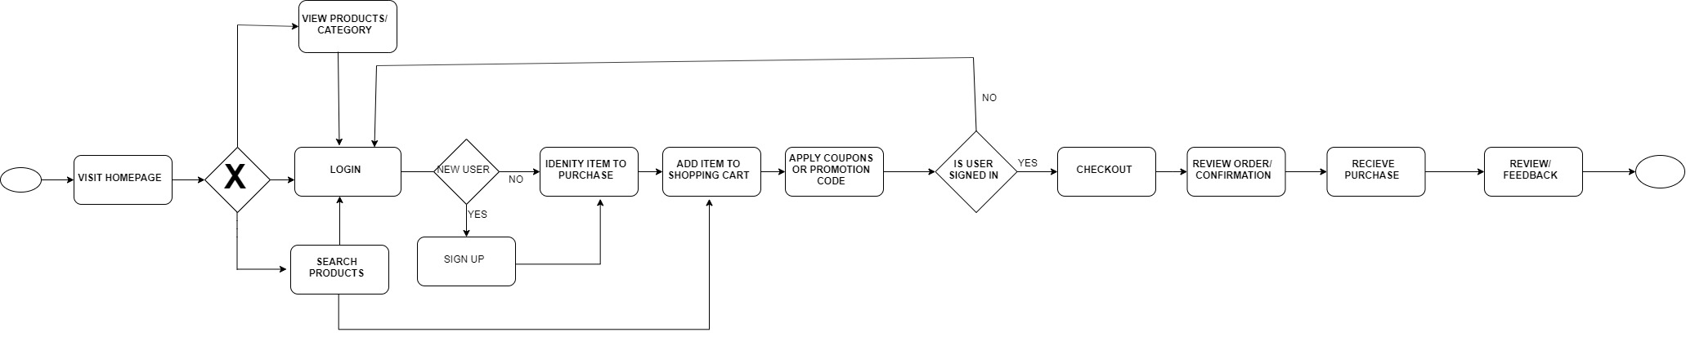

# Future work

|  |  |  |  |
| --- | --- | --- | --- |
| Future features | Purpose | Priority | Timeframe |
| Create a Multi-Vendor Platform | Allow Merchants to create stores and upload product pictures | High | October 2020 |
| Implement VR and Allow Online Art Exhibitions | Capture a new target market and expand the scope of the web app | Mid | December 2020 |